

## THE STATE UNIVERSITY OF ZANZIBAR

## SCHOOL OF COMPUTING COMMUNICATION AND MEDIA STUDIES (SCCMS)

## BACHOLAR OF INFORMATION TECHNOLOGY APPLICATION AND MANAGEMENT (BITAM)

**INDIVIDUAL ASSIGNMENT**

**COURSE NAME: WEB APPLICATION AND TECHNOLOGY (CS/INF 2215)**

**SUPERVISOR NAME: MR. MASOUD H. MMANGA**

**ACADEMIC YEAR: 2024/2025**

SECOND YEAR, FOURTH SEMESTER

**PRESENTER NAME:**

RIZIKI H. ABDALLA

**REG NO:**

BITAM/11/23/085/TZ

**SUBMITTED DATE:**

17TH APRIL, 2025

**QUESTION ONE AND TWO:**

<!DOCTYPE html>

<html lang="en">

<head>

    <title> RIZIKI HAJI ABDALLA, REG NO. BITAM/11/23/085/TZ</title>

    <link rel="icon" type="image/x-icon" href="/images/favicon.ico">

    <link rel="stylesheet" href="style.css">

</head>

<body bgcolor="pink">

    <h1>Welcome to My Wonderful Webpage</h1>

    <h2>All About Me</h2>

    <h3>About My Family </h3>

    <h4>My Favourate things </h4>

    <h5>My Hobbies</h5>

    <h6></h6>

    <marquee align=”top” loop=”infinite” behavior=”scroll” bgcolor=”ff00110ff” direction=”right”>

    <h3> WELCOME TO MY FIRST WORNDERFUL WEBPAGE </h3></marquee><big></marquee></big>

    <hr>

    <br>

    <fieldset>

    <h3> <font color="red">Hobbies</h3></font>

    <ul type = "square">

        <li>Watching Television</li>

        <li>Listining Stories</li>

        <li>Reading Magazines</li>

    <li>Cooking</li>

    </ul>

    </fieldset>

    <fieldset>

    <h3> <font color="blue">Favorite Books</h3></font>

    <ol type = "a">

        <li>"The Magic Gourd"</li>

        <li>"Lion’s Whiskers: And Other African Tales"</li>

        <li>"A Girl Called Problem"</li>

        <li>"The Last Gift"</li>

        <li>"Mfalme na Wanawe" (The King and His Sons)/li>

    </ol>

    </fieldset>

    <fieldset class="images">

    <h3>My Favorite Things in Pictures</h3>

    <img src="image/cat.jpg" alt="CAT">

    <img src="dog.jpg" alt="DOG">

    <img src="image/tree.jpg" alt="TREE">

    </fieldset>

    <hr>

    <fieldset>

    <h3>Favorite Websites</h3>

    <ul>

        <li><a href="https://www.wikipedia.org">wikipedia</a></li>

        <li><a href="https://www.google.com">Google</a></li>

        <li><a href="https://www.youtube.com">YouTube</a></li>

        <li><a href="https://www.canva.com">Canva</a></li>

        <li><a href="https://www.bbc.com">BBC News</a></li>

    </ul>

    </fieldset>

    <fieldset>

    <table border="1">

        <thead>

            <th>MONDAY</th>

            <th>TUESDAY</th>

            <th>WENESDAY</th>

            <th>THURSDAY</th>

            <th>FRIDAY</th>

        </thead>

        <tr>

            <td>Studying</td>

            <td>Studying</td>

            <td>Studying</td>

            <td>Studying</td>

            <td>Studying</td>

        </tr>

        <tr>

            <td>Cooking</td>

            <td>Cooking</td>

            <td>Cooking</td>

            <td>Cooking</td>

            <td>Cooking</td>

        </tr>

        <tr>

            <td>Resting</td>

            <td>Restig</td>

            <td>Resting</td>

            <td>Relaxing</td>

            <td>Resting</td>

        </tr>

    </table>

    </fieldset>

</body>

</html>

QUESTION ONE AND TWO : OUTPUT

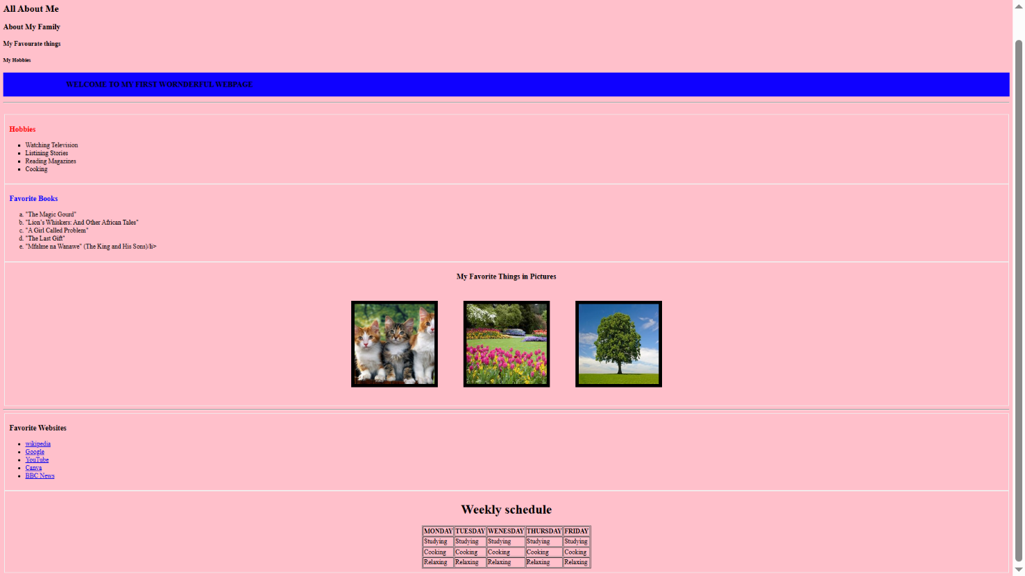

QUESTION THREE:

<!DOCTYPE html>

<html lang="en">

<head>

    <meta charset="UTF-8">

    <meta name="viewport" content="width=device-width, initial-scale=1.0">

    <title>FORM</title>

    <link rel="stylesheet" href="style.css">

</head>

<body bgcolor ="light ff22002002">

    <form id="myform">

        <fieldset>

            <label for="fname">First name:</label><br>

            <input type="text" id="fname" name="fname"><br>

            <label for="lname">Last name:</label><br>

            <input type="text" id="lname" name="lname"><br>

            <label for="email">Email:</label><br>

            <input type="emailid" id="email" name="email"><br>

            <label for="password">Password:</label><br>

            <input type="password" id="password" name="password"><br>

        </fieldset>

        <fieldset>

            <label for="gender">Gender:</label><br>

            <input type="radio" id="male" name="male" value="male">

            <label for="male">Male</label><br>

            <input type="radio" id="female" name="female" value="female">

            <label for="female">Female</label><br>

        </fieldset>

        <fieldset>

            <label for="intrest">Intrest:</label><br>

            <input type="checkbox" id="intrest1" name="intrest1" value="Cooking">

            <label for="intrest1"> Watching Television</label><br>

            <input type="checkbox" id="intrest2" name="intrest2" value="Painting">

            <label for="intrest2"> Reading Magazine</label><br>

            <input type="checkbox" id="intrest3" name="intrest3" value="Driving">

            <label for="intrest3"> Cooking</label><br>

            <input type="button" onclick="Submit" value="Submit" id="button">

        </fieldset>

      </form>

</body>

</html>

QUESTION THREE: OUTPUT:

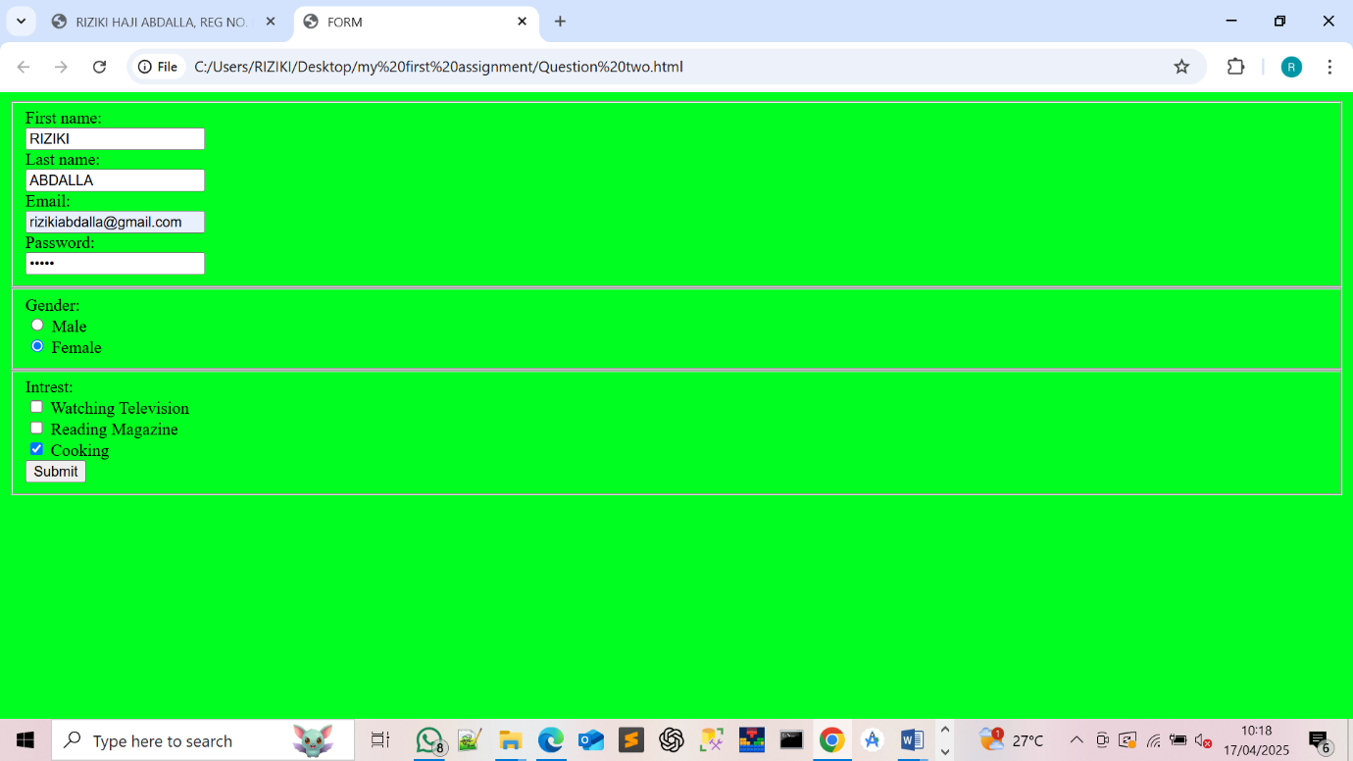

QUESTION FOUR AND FIVE:

@media (max-width: 600px) {

body {

background-color: #f5f4f6;

color: #378;

margin: 40px;

text-align: center;

}

h1 {

color: #2b3e55;

margin-bottom: 20px;

}

p {

font-size: 18px;

line-height: 1.6;

}

a {

color: #3398de;

text-decoration: none;

font-weight: bold;

transition: color 0.3s ease;

}

#button {

padding: 10px 20px;

background-color: #3447db;

color: white;

border: none;

border-radius: 6px;

cursor: pointer;

font-size: 16px;

transition: background-color 0.3s ease;

}

a:hover {

color: #1abc9c;

}

button:hover {

background-color: #1abc9c;

}

.img {

width: 1%;

max-width: 1px;

height: auto;

}

}